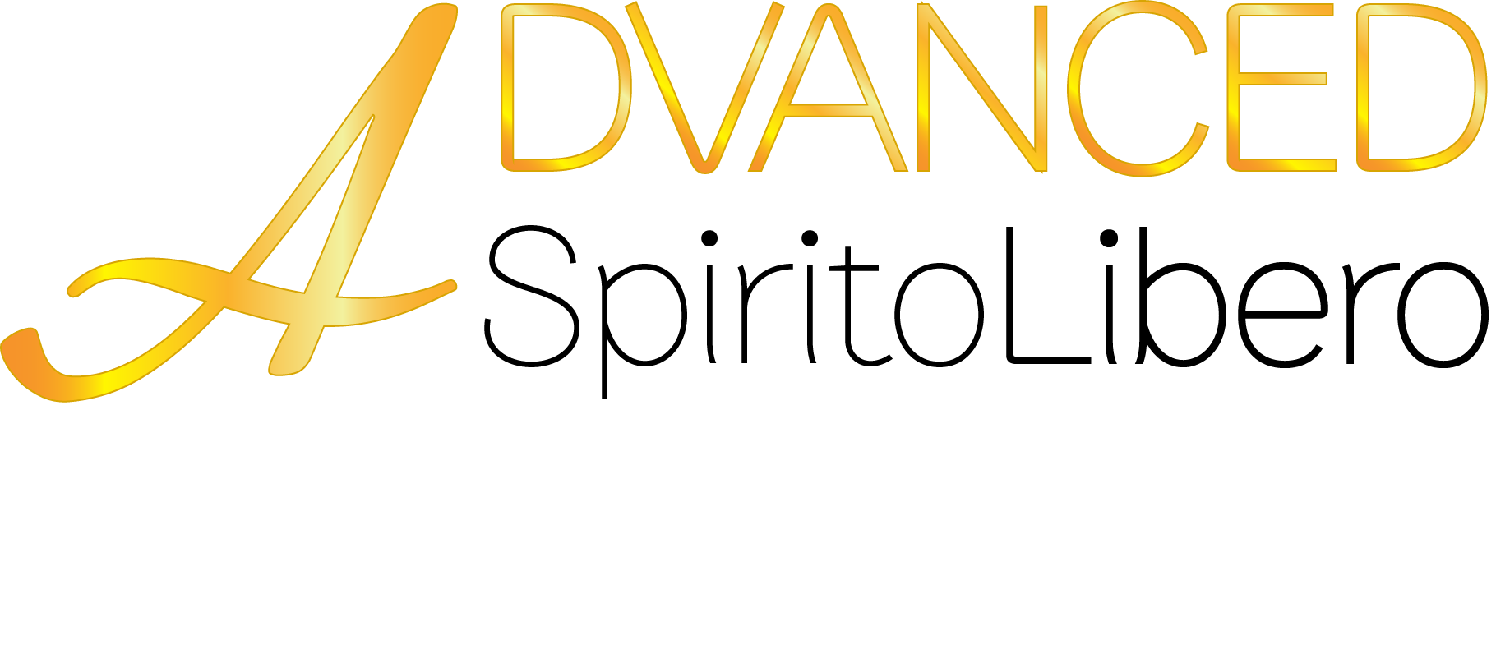

TADELAKT

Description

TADELAKT is a Moroccan typical wall finishing, smooth to the touch with an aged undulate look. It is suitable for internal and external wall surfaces and for particularly humid environments. It is a mixture based on white agricultural lime, calcareous inerts, clays and special additives, which make it easy to apply.

colour range

TADELAKT is produced in white version.
Check our color range on www.venetianplastershop.com.au

surface preparation
TYPE OF SURFACE | PRELIMINARY TREATMENTS
Any Surface (except render) | Apply 1 coat of Undercoat Sealer before priming
Old plasterworks | Brushing, eventual power washing and a coat of CONSOLIDATING PRIMER.
Render/ Base coat render | Coat of PRIMUS NATURALE primer.
Medium density | Coat of PRIMUS NATURALE primer.
Plasterboard | Coat of PRIMUS NATURALE primer.
Plaster | Coat of PRIMUS NATURALE primer.
Concrete | Coat of PRIMUS NATURALE primer.
Polished lime finishing | Accurate sanding and a coat of PRIMUS NATURALE primer.
Washable paints | Coat of PRIMUS NATURALE primer.
Non-mineral decorative finishings | Coat of PRIMUS NATURALE primer.
Plastic coating | A coat of oil based primer then a coat of PRIMUS NATURALE primer.
Note: Advanced Spirito Libero recomends that our entire range of lime based natural materials is used only by highly skilled or licensed tradespeople with extensive experience in this field. It is the responsibility of the applicator to understand the application method and the procedure involved in order to obtain a satisfactory outcome. Advanced Spirito Libero recomends that architects, builders and clients appoint only experienced applicators in the relevant lime-based materials to ensure they'll be able to deliver the same finish as per the sample shown.
As with any lime-based material this product may change the appearance over time due to the ageing process caused by weather conditions"
To slow down this process the use of siloxane impregnating sealer is recomended over time.
For exteriors please protect treated surfaces from raining during application and for the time required to allow product to fully harden (48h), fail to do so, some trace of efflorescence might appear and no warranty will be applied.
Ensure that a sufficient quantity of the same batch is available to complete the entire job or at least to complete whole sections that will not reveal differences in shade.
Advanced Spirito Libero provides no warranty expressed or implied against damage due to movement of the substrate structure.

product mixing
TADELAKT is sold in a white powder form, and it has to be mixed with 30% of clean water (max 3L per bucket).
In case of necessity or in case of high temperatures, it is recommended to wash the surface with water, before to apply TADELAKT.

FIRST COAT

To obtain a better job it is advisable to use a venetian plaster trowel, trying to use it in an uniform and homogeneous way.
Once the first coat is applied, the process has to be complete within 48h.

SECOND COAT

It is possible to apply the second coat only when the first one is totally dry and it is important to apply it in a homogenous way creating a smooth surface without any lump or imperfection. Be careful to not make it polished.

THIRD COAT
The last coat should be applied when the previous one is not totally dry, pressing the product with the polishing trowel, which has to be hold in a quite inclined way, and smoothing the surface without polishing it (as a normal marmorino), but keep it a bit rough.
In the original countries of this product, TADELAKT is applied using specific flat and very hard stones.

PROTECTIVE FINISHINGS
INTERNALS:
PRODUCT |  | APPLICATION
OLIVE SOAP |  | Allow the surface to dry for at least 48hours. Then apply the soap with a venetian plaster trowel or sponge. Apply the product more than once on wet until it is completely absorbed, trimming perfectly. After 24 hours, run a cloth on the surface to remove the superficial film of dust of soap, which was not absorbed.
EXTERNALS:
EXTERNAL IMPREGNATING SEALER |  | After 48 hours apply 1 coats with a brush until saturation
ENVRONMENTAL CONDITIONS FOR THE APPLICATION PHASE
The ambient temperature must be between +10°C and +30°C, while the relative humidity must be less than 85% for at least a day. It is better to avoid this phase on windy days or when the sun is shining or when it is raining.

PRESERVATION
The product maintains its unaltered features for 12 months, if it is correctly preserved. Store it in a dry, close and covered places, away from humidity and rain.

SAFETY NORMS
Avoid contacts with skin and eyes, and in case wash immediately the part with water. For further information, consult our safety sheet.

DISPOSAL
This product should be disposed of in accordance with existing laws. Empty plastic vases or paper sacks must be recycled.

TECHNICAL DATA
Aspect | Semi-polished marble with natural shadings
Packaging | 10 Kg. net plastic bucket
Application tools | Venetian plaster trowel – natural stone
Specific weight | 1,60 ± 0,05 Kg/l
Theoretical yield | 1,70 ÷ 2,05 Kg/m² including 3 coats
Aggregate grading curve | 0,02 ÷ 0,70 mm
Coating thickness | 1,10 ÷ 1,40 mm including 3 coats
Touch dry | 5 hours with an ambient temperature of 20°C
Deep dry | 48 hours with an ambient temperature of 20°C
Stable carbonation | 180 days
Recoating | 12 hours with an ambient temperature of 20°C
PH after 30 days | 12,5 ± 0,2
Inflammability | Not inflammable - class A1
Permeability to water vapor | high 0,06m (Reference standard: UNI EN ISO 7783-2:2001)

